AWS VPC PEERING

Student Project Report

Prepared by: Milind Kailas Tajane

Environment: Amazon Web Services (AWS)
Region: Asia Pacific (Mumbai — ap-south-1)

Project summary
This project demonstrates private network communication between two Amazon Virtual Private Clouds (VPCs) using VPC Peering. Route tables direct traffic across the peering connection, and security group rules control which traffic is allowed. EC2 instances were used to test connectivity in both directions and to demonstrate the effect of removing and restoring an ICMP rule.

Objectives
The objectives of this project were to configure two VPCs, connect them using VPC Peering, route traffic between the VPC CIDR ranges, apply security group controls, and validate network connectivity using ICMP ping tests.

Network design
The lab uses two IPv4 VPC networks in the AWS Mumbai region:

Component | Configuration
VPC A | ewb-vpc-a — 10.10.0.0/16
VPC B | ewb-vpc-b — 10.20.0.0/16
Public subnet (VPC A) | ewb-a-public — 10.10.1.0/24
Private subnet (VPC A) | ewb-a-private — 10.10.2.0/24
Private subnet (VPC B) | ewb-b-private — 10.20.1.0/24
VPC Peering | ewb-a-b-peer — Active
Internet Gateway | ewb-igw-a — attached to VPC A

Routing and security
The public route table for VPC A contains a default route to the Internet Gateway and a route for 10.20.0.0/16 through the peering connection. The private route table in VPC A routes 10.20.0.0/16 through the peering connection. The private route table in VPC B routes 10.10.0.0/16 through the peering connection. Security groups permit SSH only from the intended bastion source and ICMP between the test hosts as configured for the lab.

EC2 test hosts
The lab used a bastion host in VPC A's public subnet, App-A in VPC A's private subnet, and App-B in VPC B's private subnet. SSH agent forwarding allowed access to the private instances without copying the private key onto the bastion host.

Validation and results
ICMP tests showed successful communication from App-A (10.10.2.10) to App-B (10.20.1.10) and from App-B back to App-A. A controlled-failure test was performed by temporarily removing the inbound All ICMP – IPv4 rule from App-B's security group. The ping from App-A then showed 100% packet loss. After restoring the rule, the ping succeeded again with 0% packet loss. This demonstrates that the peering routes were in place and that the security group rule controlled the tested ICMP traffic.

Conclusion
The project successfully demonstrated VPC Peering between two VPCs, routing between their private CIDR ranges, and security-group-based traffic control. Bidirectional ping tests succeeded, failed when the relevant ICMP rule was removed, and succeeded again after the rule was restored.
Public-sharing note: This version redacts the terminal lines showing the local SSH key path and fingerprint from the App-A to App-B evidence screenshot. Never publish private keys, AWS credentials, or session tokens.

The following pages contain the supplied screenshots. Images are scaled to fit the report page while preserving their aspect ratio.

Evidence 1 — VPC A configuration
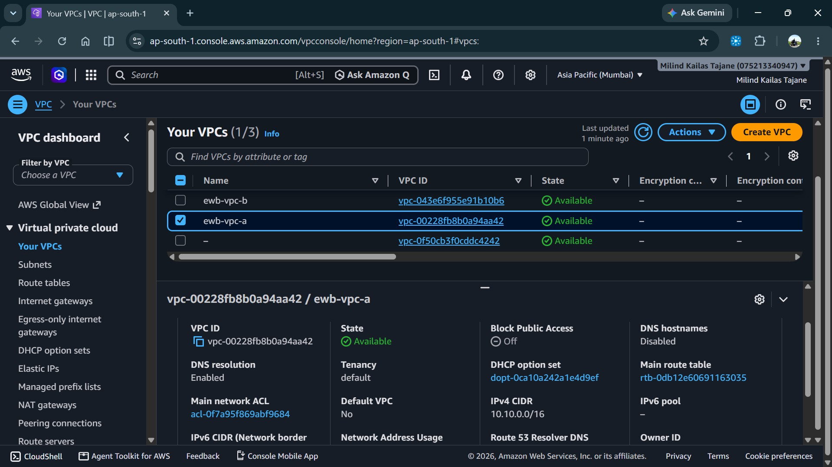

Evidence 2 — VPC B configuration
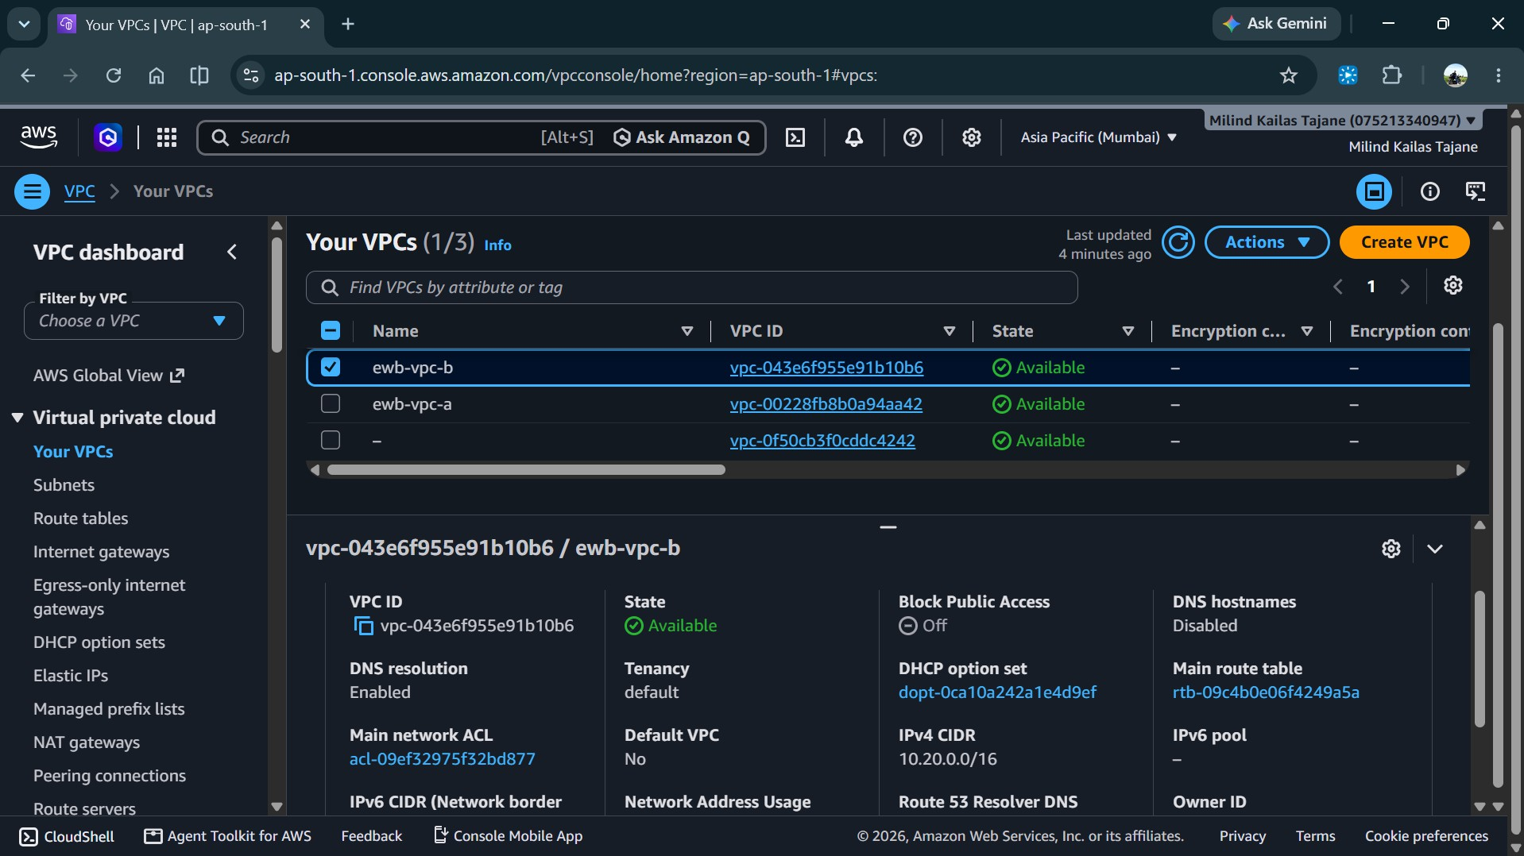
Evidence 3a — VPC A public subnet

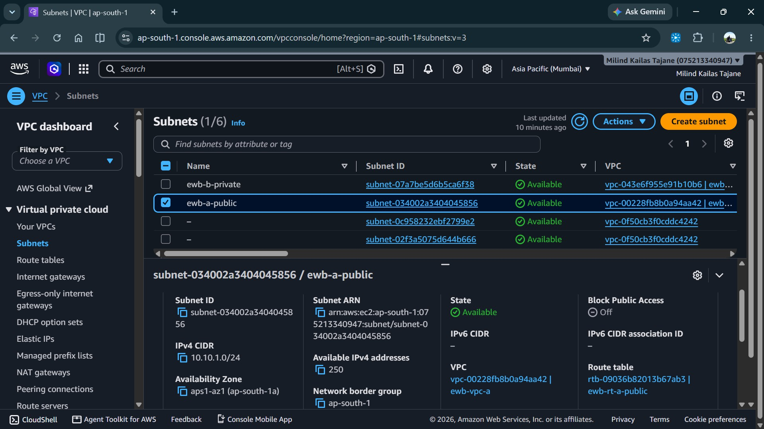

Evidence 3b — VPC B private subnet

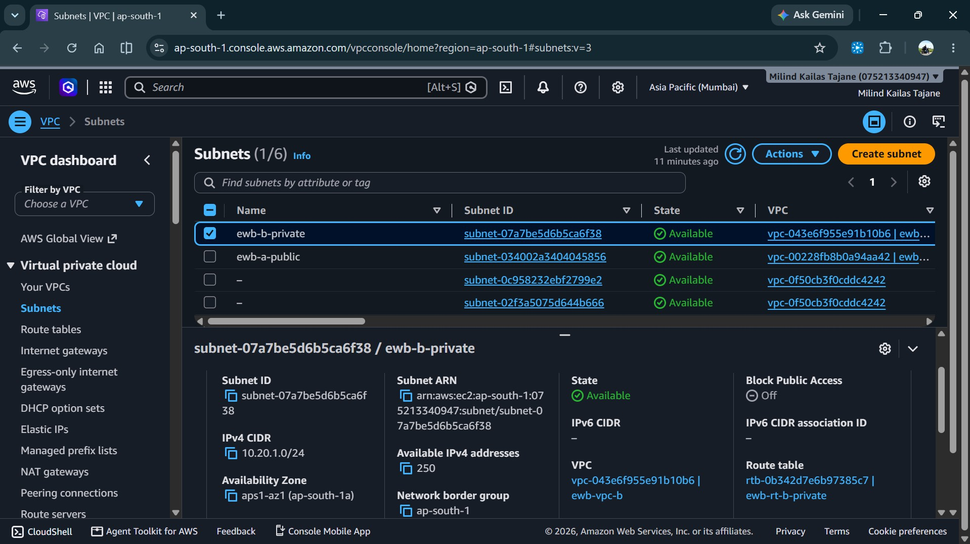
Evidence 3c — VPC A private subnet

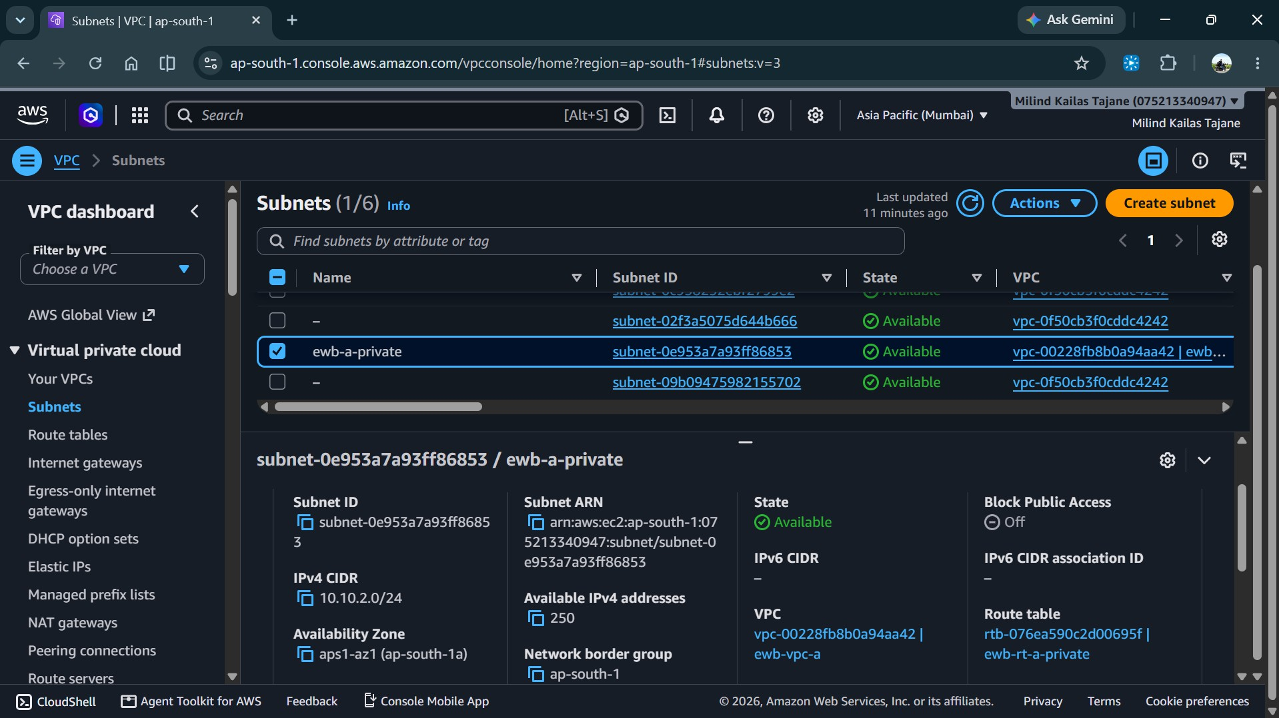

Evidence 4 — Active VPC Peering connection

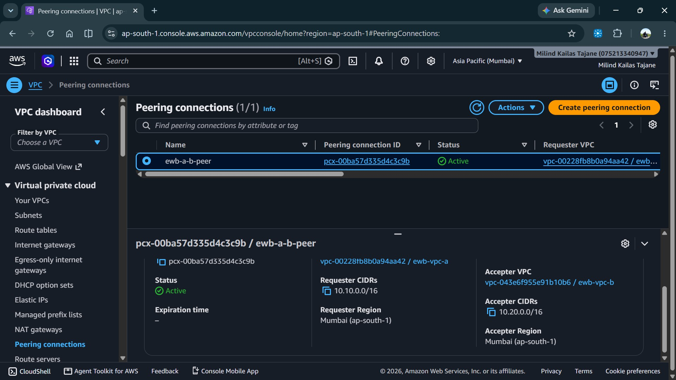
Evidence 5 — VPC A public route table

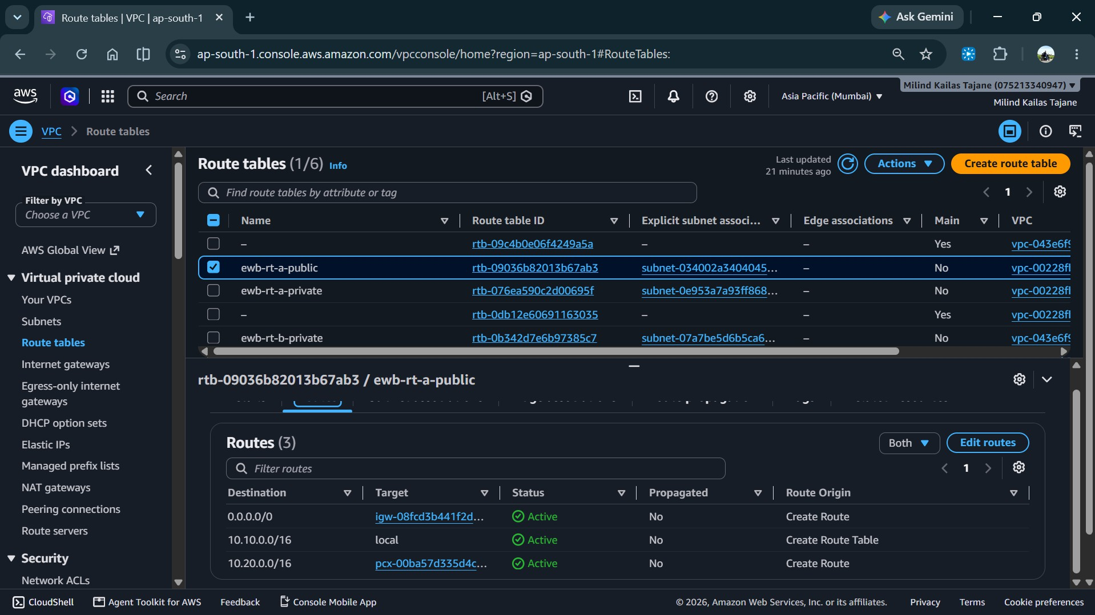

Evidence 6 — VPC A private route table

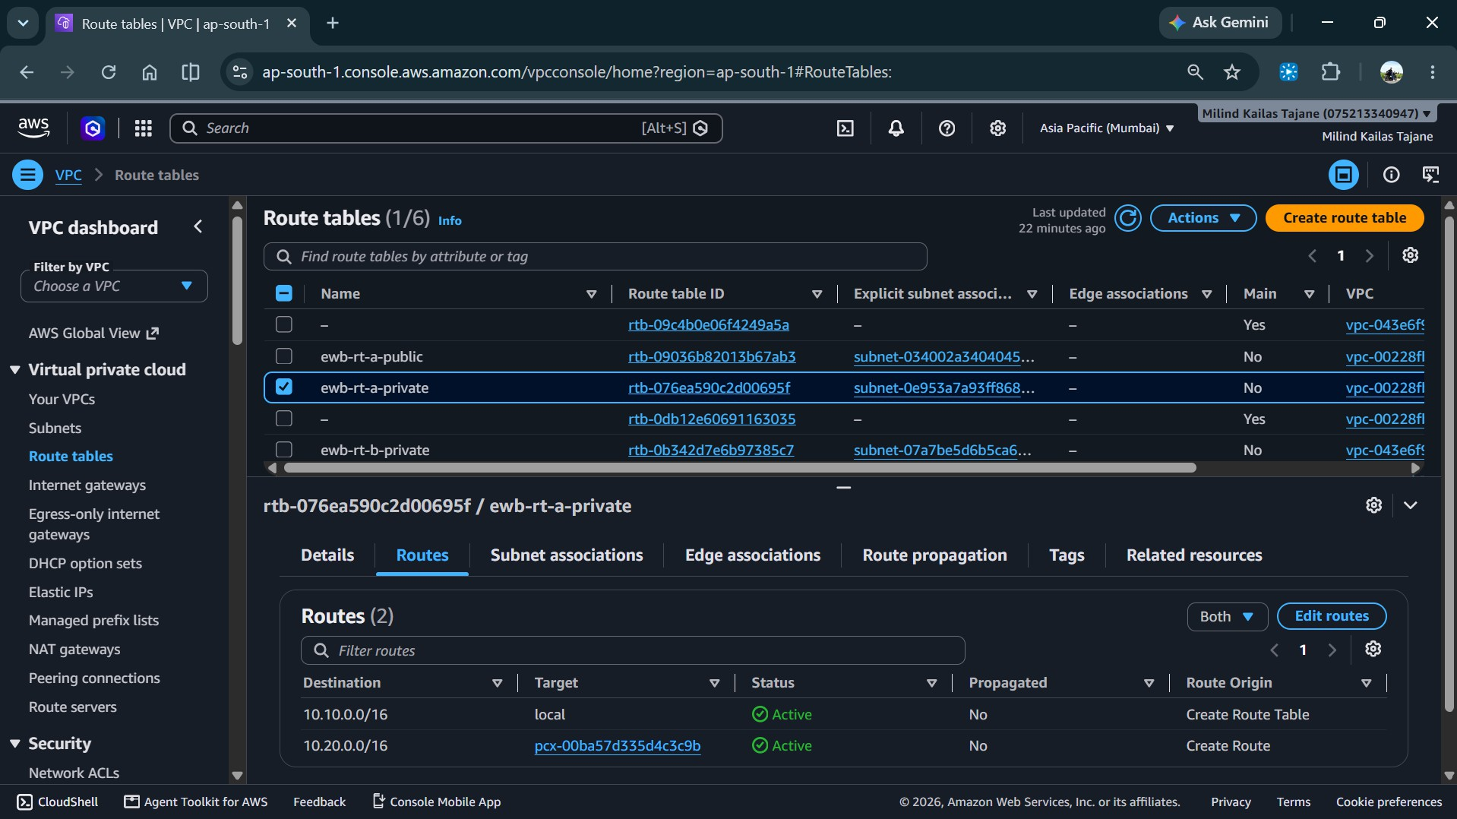

Evidence 7 — VPC B private route table

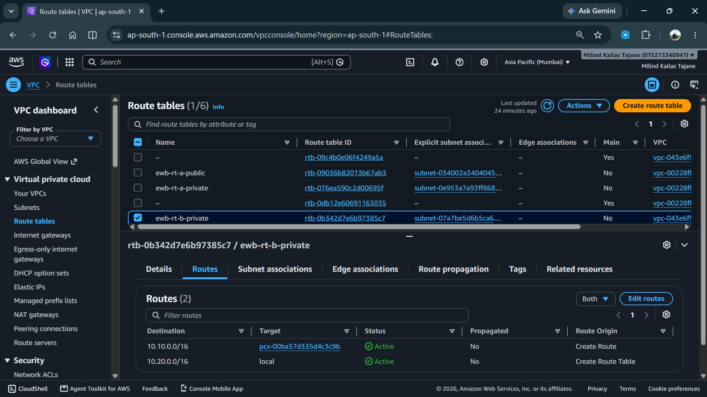

Evidence 8a — Bastion security group

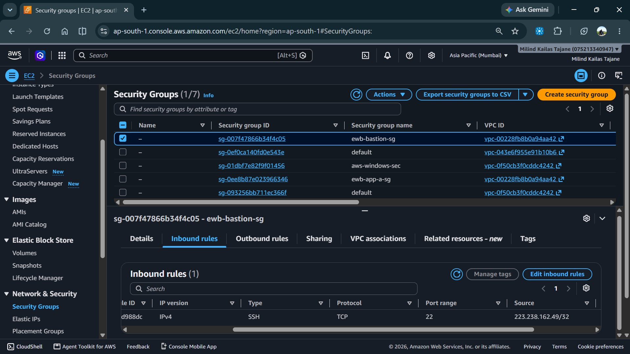
Evidence 8b — App-A security group

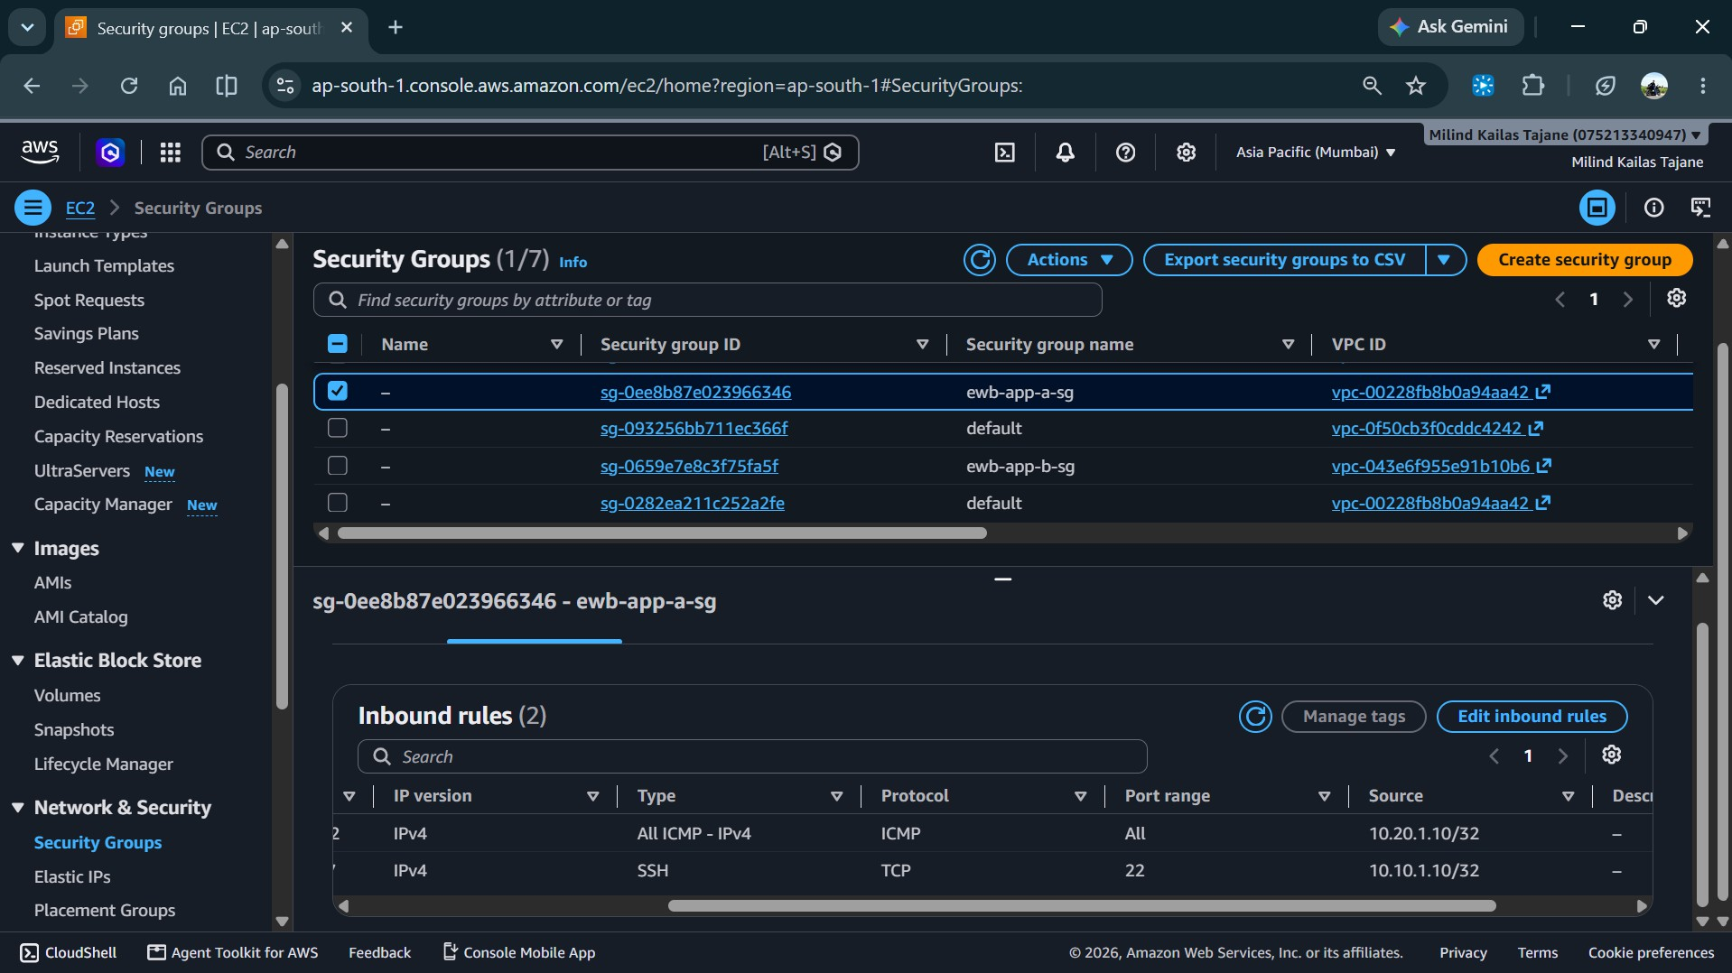

Evidence 8c — App-B security group

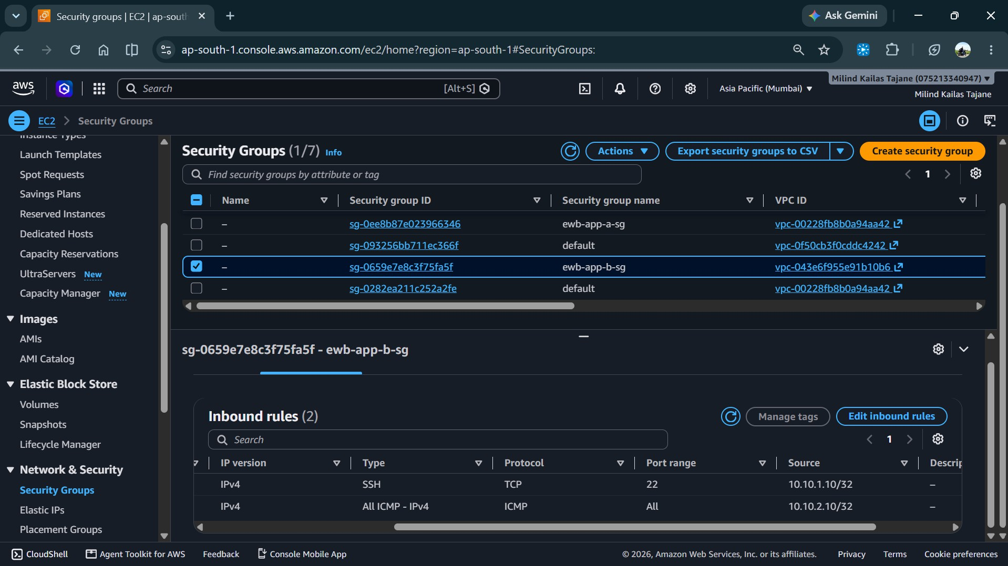
Evidence 9a — Bastion EC2 instance

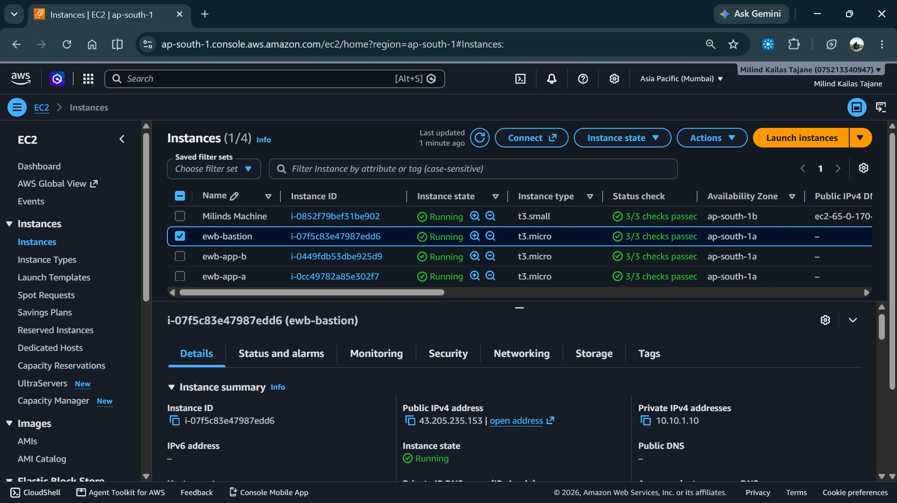

Evidence 9b — App-A EC2 instance

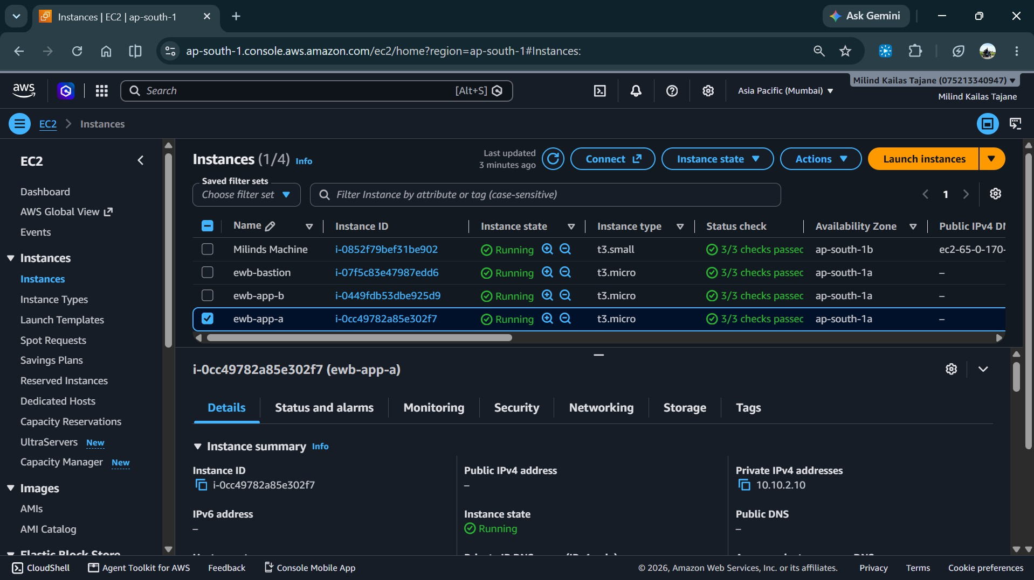
Evidence 9c — App-B EC2 instance

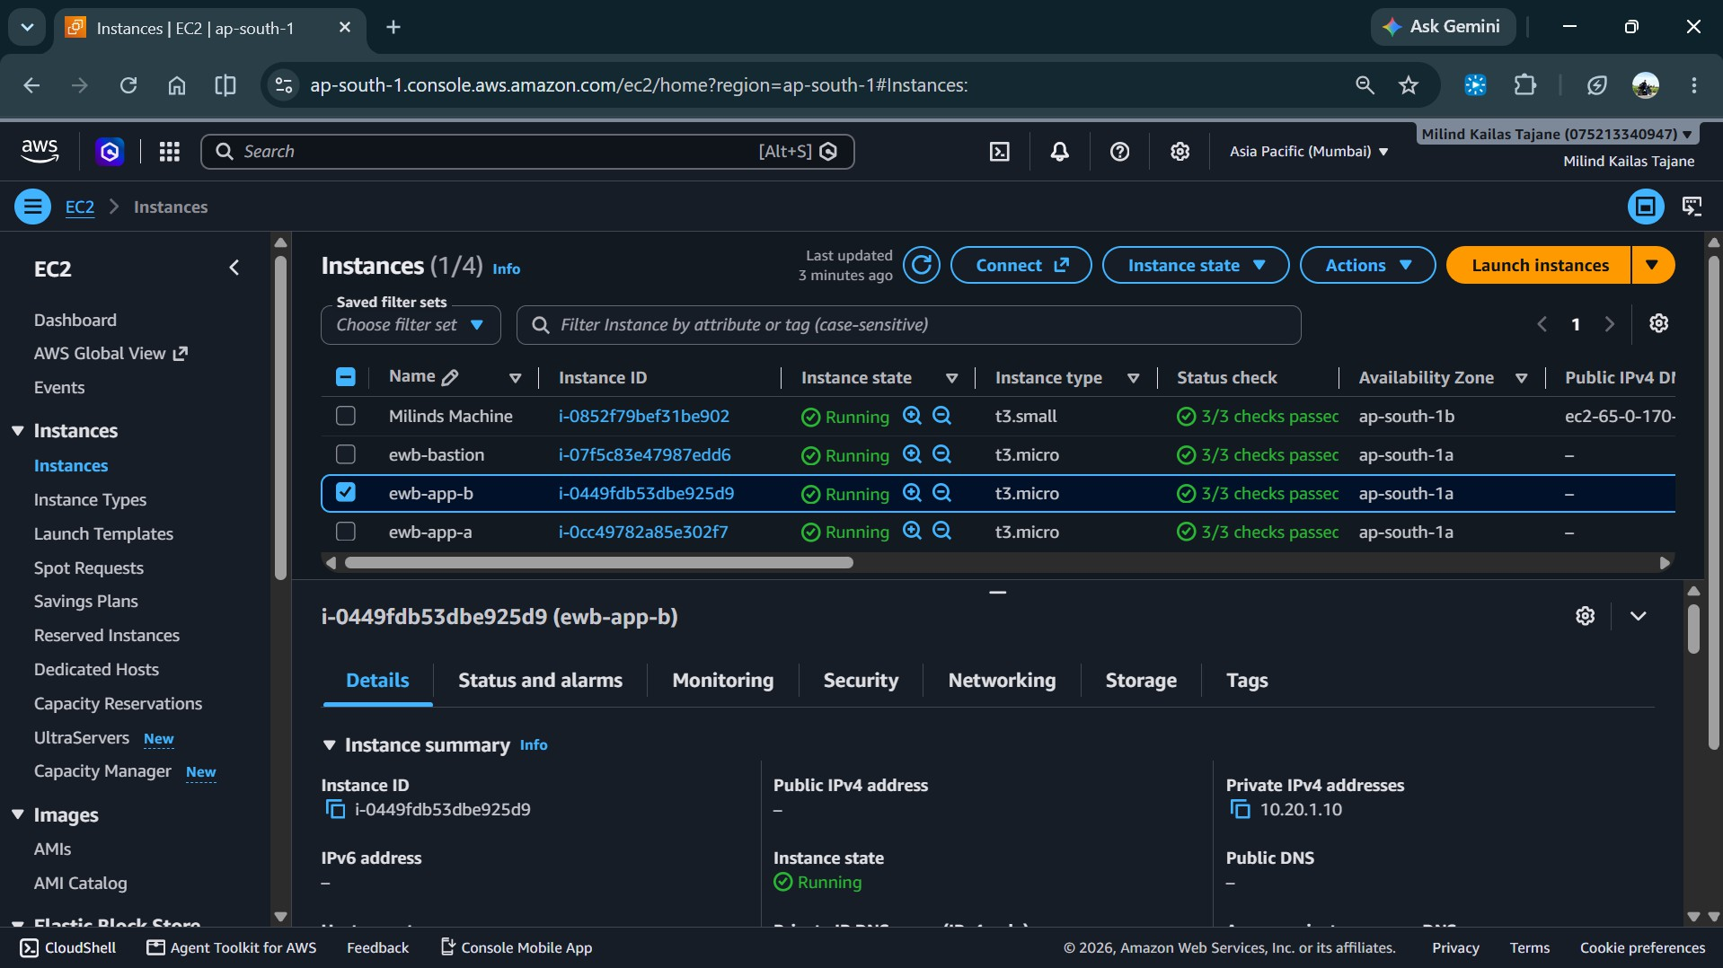

Evidence 10 — Successful ping: App-A to App-B

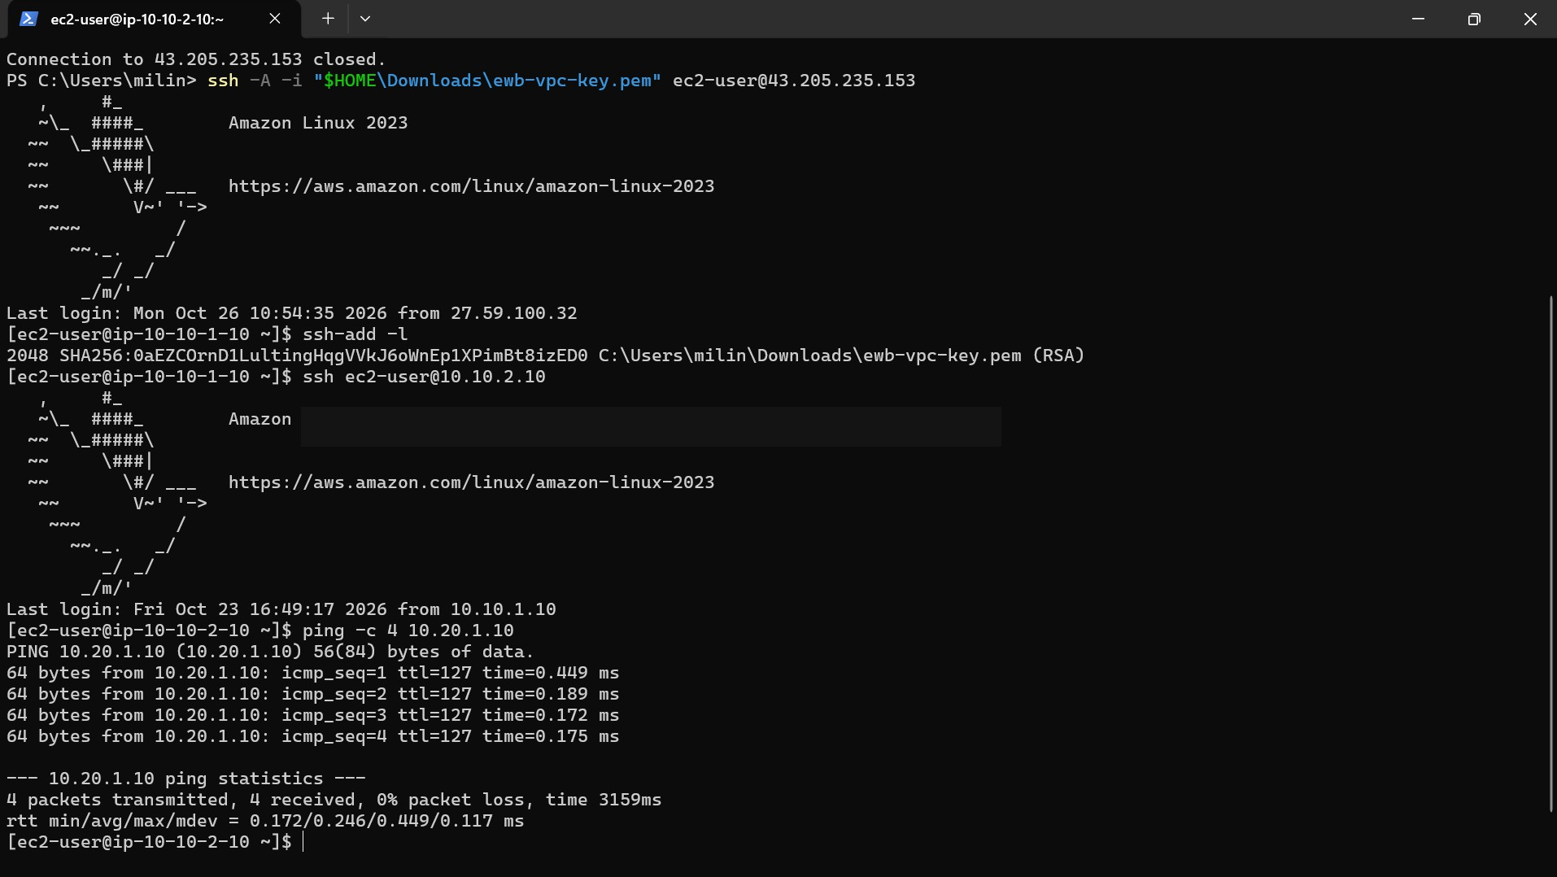

Evidence 11 — Successful ping: App-B to App-A

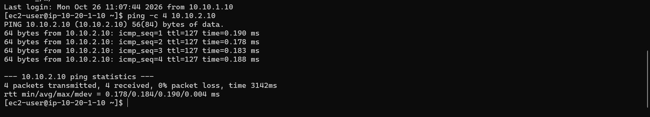

Evidence 12 — Controlled ICMP failure

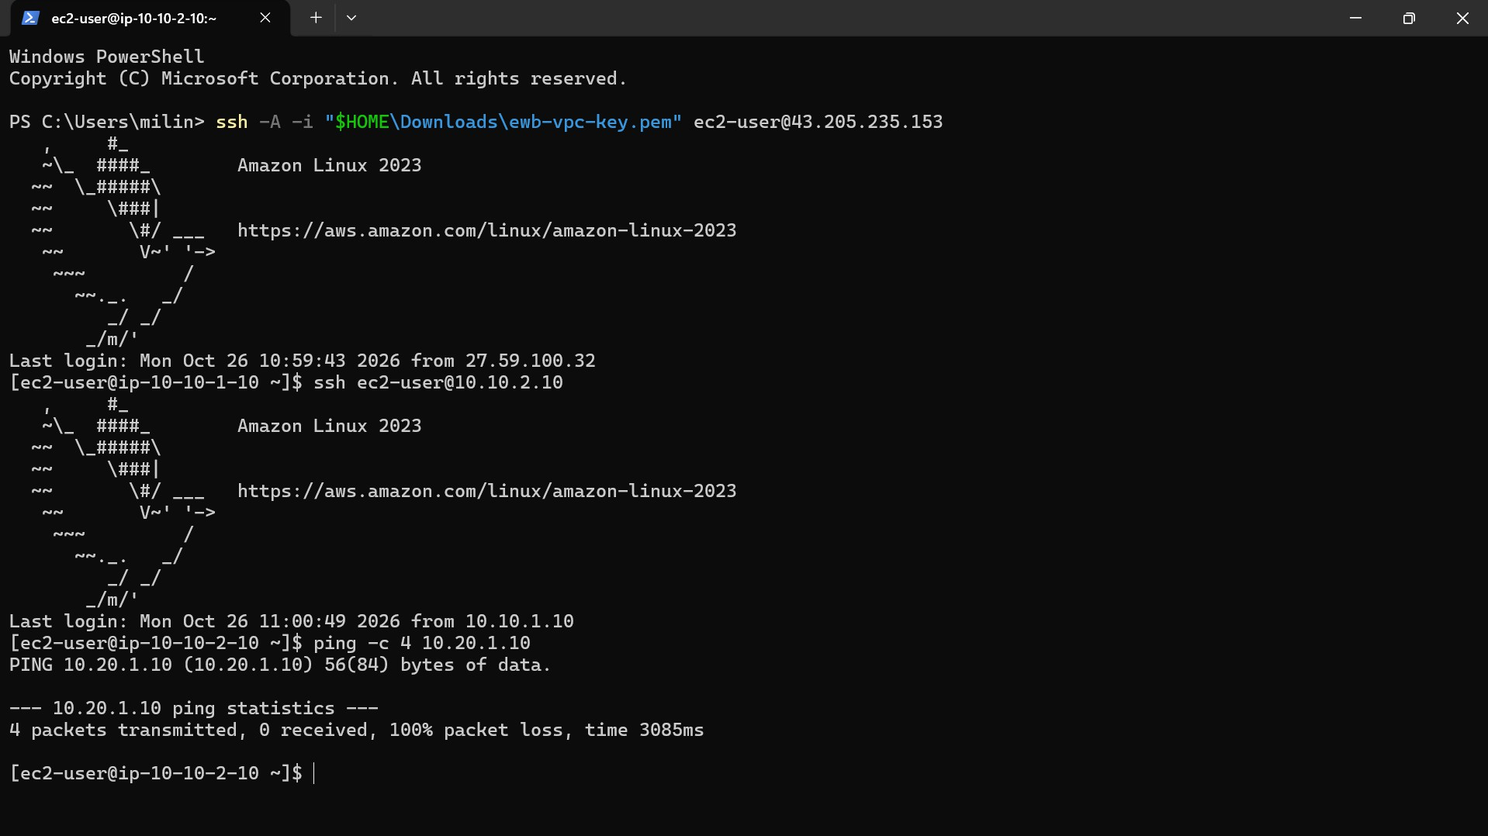
Evidence 13 — Connectivity restored

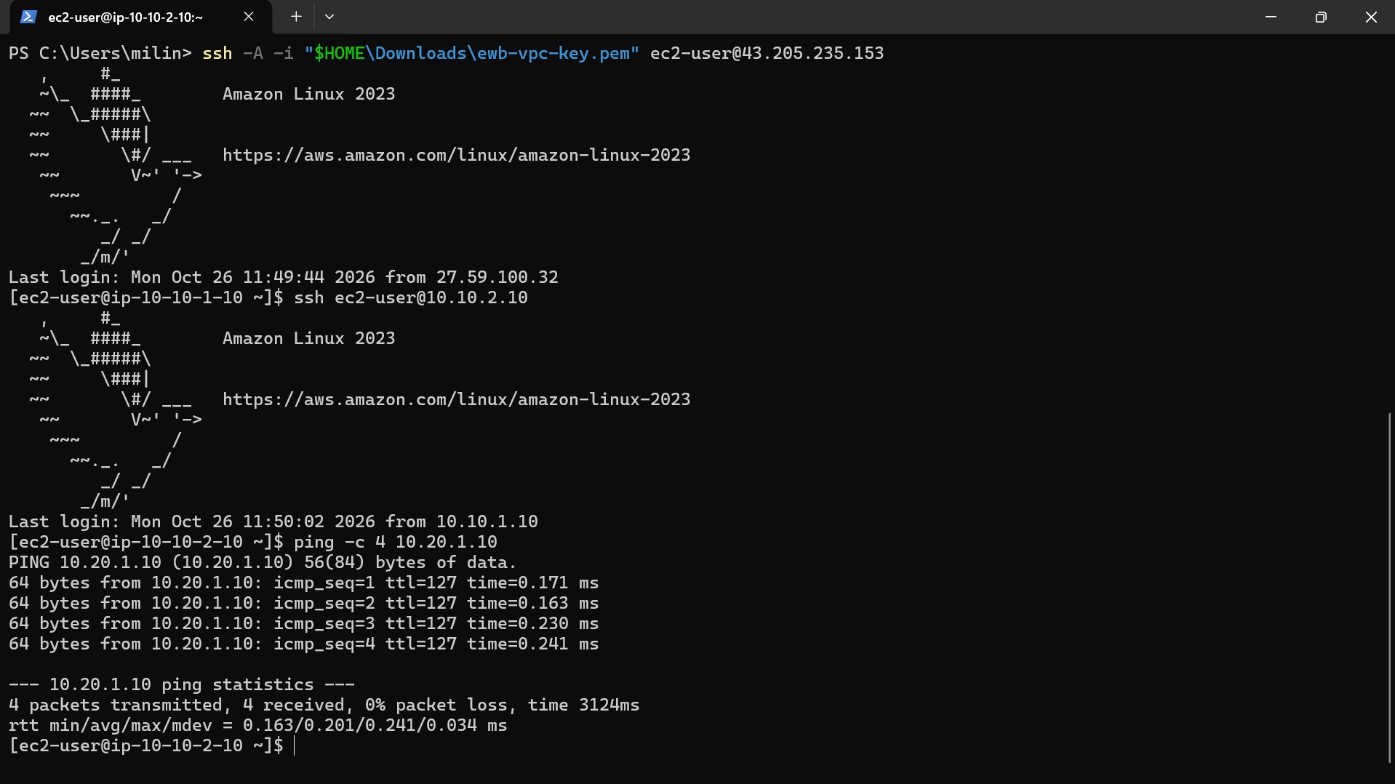

Evidence 14 — Internet Gateway attached to VPC A

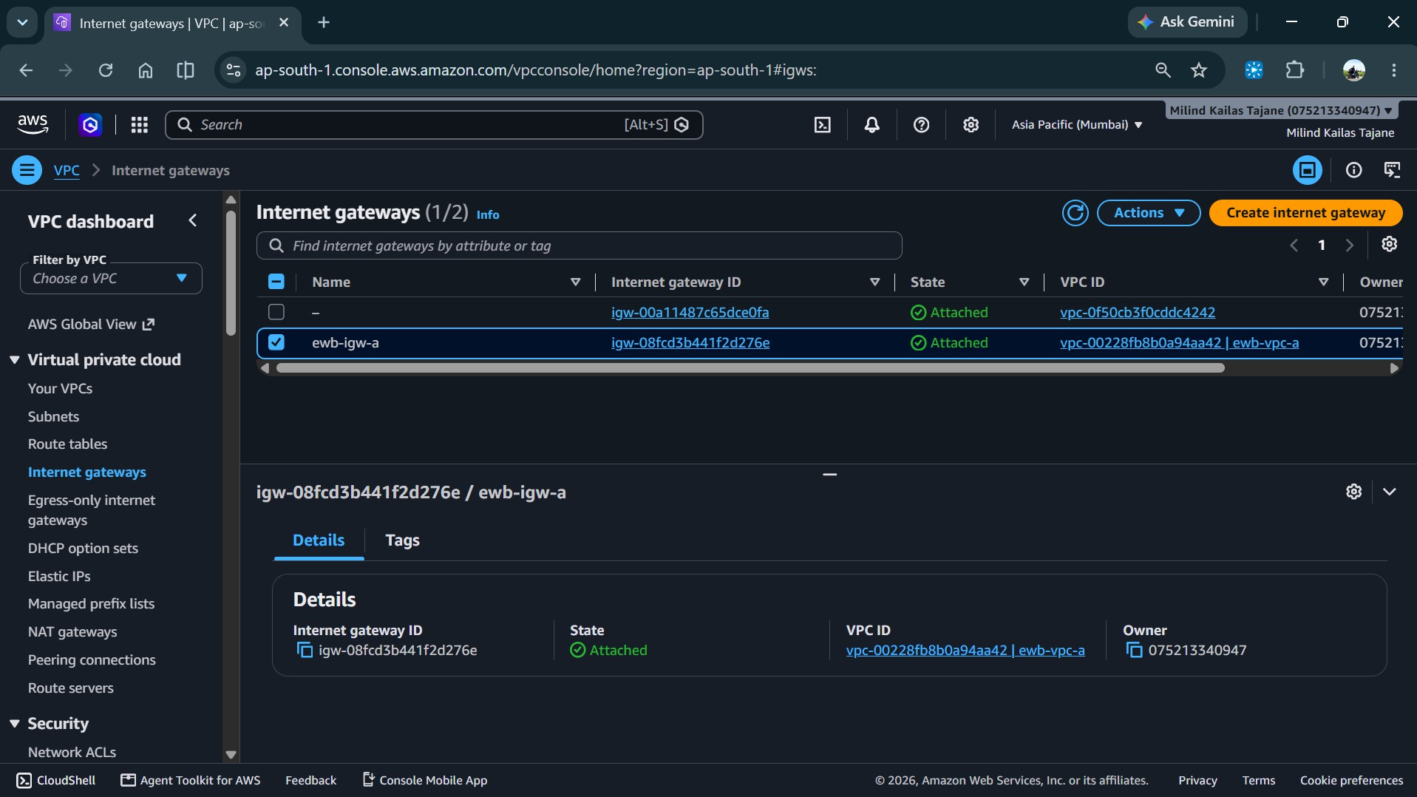

AWS VPC Peering Architecture

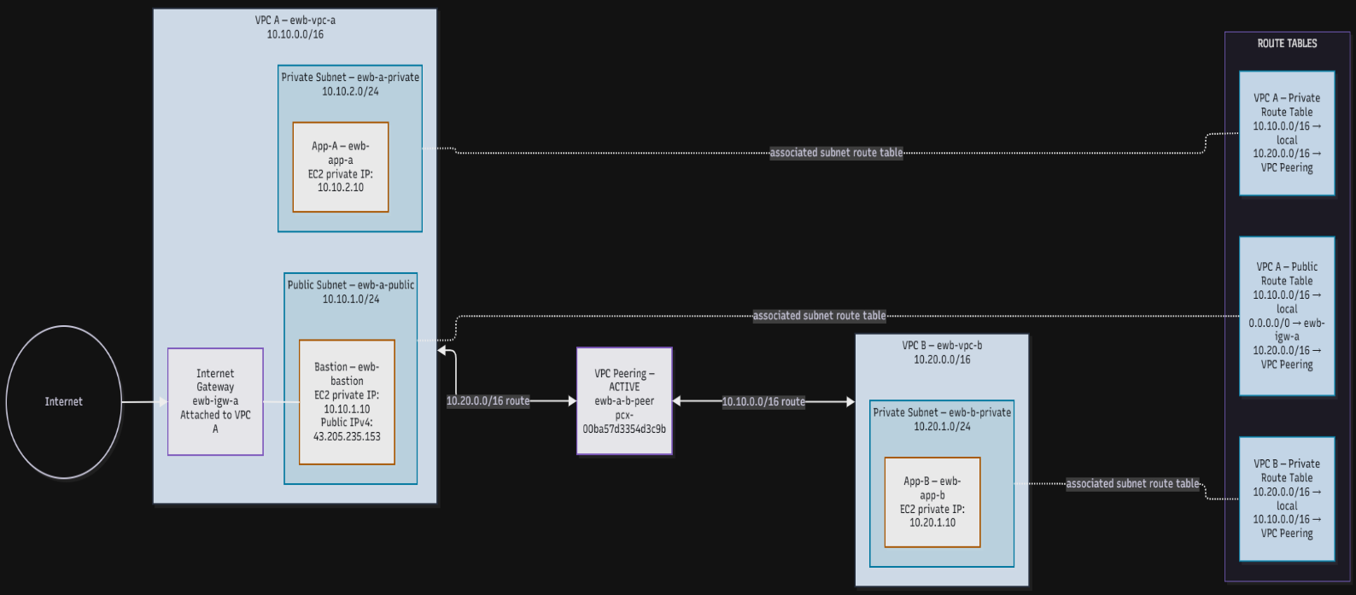

Architecture Overview

The architecture demonstrates communication between VPC A (10.10.0.0/16) and VPC B (10.20.0.0/16) through an active VPC peering connection. Route tables direct traffic between the two networks, while security groups control permitted traffic. App-A (10.10.2.10) and App-B (10.20.1.10) were used to verify connectivity in both directions.

VPC Route Tables and Traffic Routing

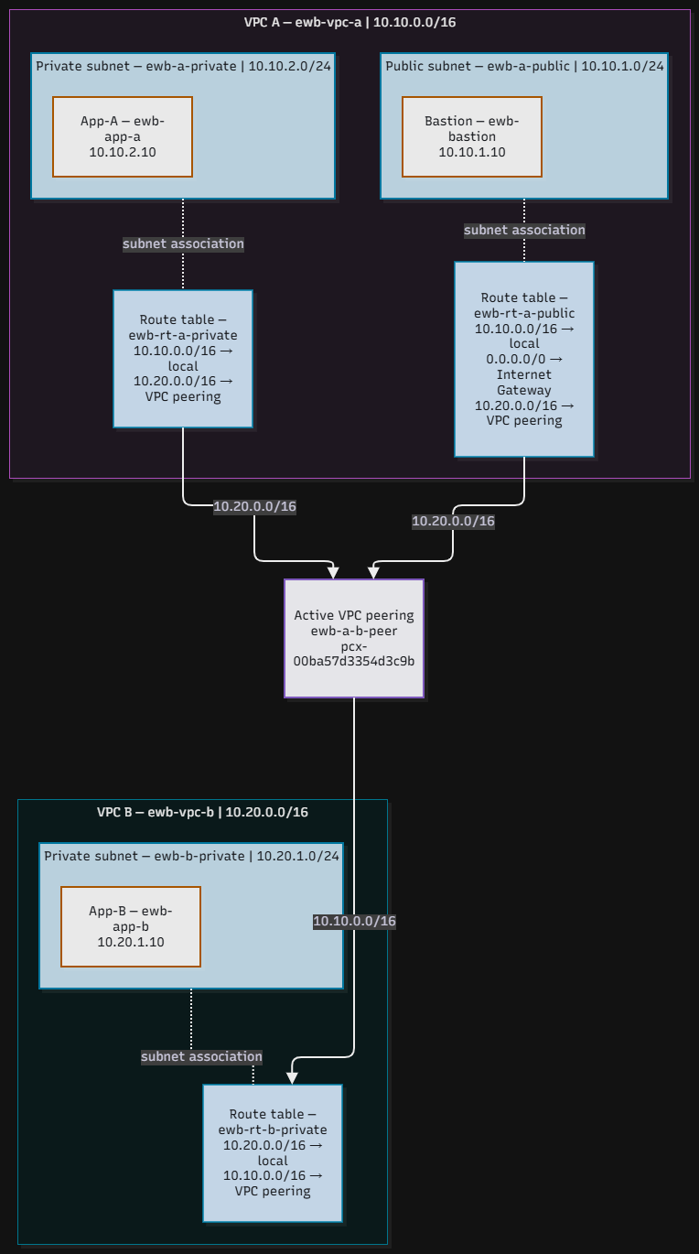

Routing Overview

The route tables direct traffic between VPC A (10.10.0.0/16) and VPC B (10.20.0.0/16) through the active VPC peering connection. The VPC A public route table also includes a default route to the Internet Gateway. The private route tables contain routes to the remote VPC CIDR through the peering connection.

Security Groups and Access Control

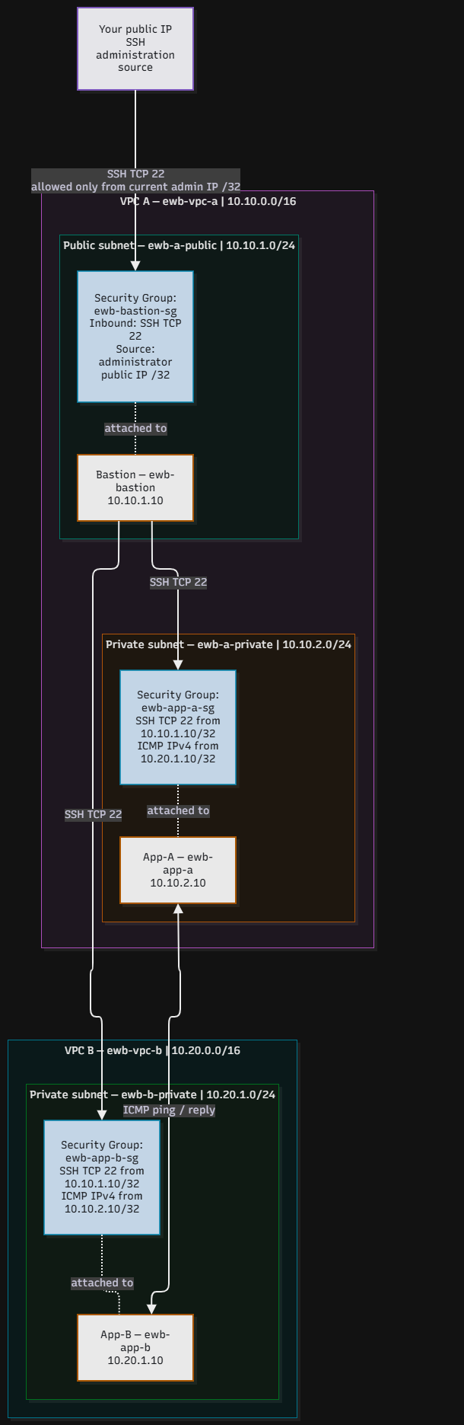

Security Controls Overview

Security groups control access to the EC2 instances used in this lab. SSH access is restricted to the configured source, while ICMP rules permit the intended connectivity tests between App-A and App-B. The controlled-failure test demonstrated that removing the relevant ICMP rule interrupted ping traffic, and restoring the rule allowed connectivity to succeed again.

Connectivity Testing, Failure and Recovery

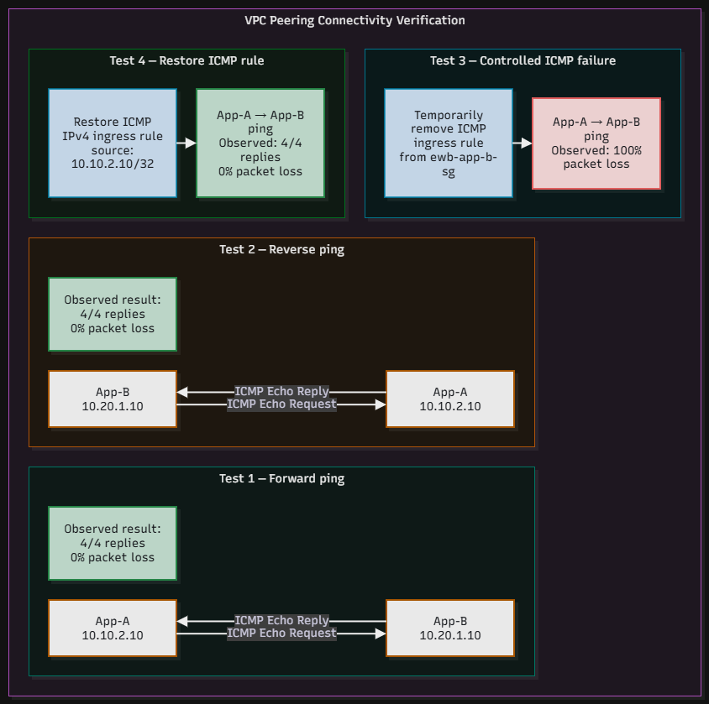

Testing and Recovery Summary

Connectivity was tested between App-A (10.10.2.10) and App-B (10.20.1.10) in both directions. The ping tests succeeded when the required ICMP security group rule was present. Temporarily removing the relevant ICMP rule caused the test to fail, and restoring the rule returned connectivity to a successful state.

